**Multipurpose Website With Multi Features Name as Shoppeal**

2006890

T.Y. B.Sc. IT ( Semester VI)

## K. J. Somaiya College of Science and Commerce

***Autonomous, Affiliated to University of Mumbai***

**Vidyavihar , Mumbai - 400 077**

**DEPARTMENT OF INFORMATION TECHNOLOGY**

**C ERTIFICATE**

*This is to certify- that the project entitled*

**‘Multipurpose Website With Multi Features Name as Shoppeal’**

*Undertaken by*

#### *Sudhanshu Singh (20-06890)*

*In fulfilment for B.Sc. I.T. Degree (Semester 6) Examination has been completed by him/her. This project had not been submitted for any other examination and does not form a part of any other course undergone by the candidate.*

*This is to further certify that he/she has completed all required phases of the project*

( Ms. Anushree Sukhi ) (Mr. Prakash Patil) Project Guide Head of the Department

College Seal External Examiner

# Acknowledgement

I would like to thank my project **Guide Prof.Anushree Sukhi** Ma’am for supporting and coordinating and taking so much interaction between us for the discussion of the project.

I would like to thank **Head Of the Department, Prakash Patil Sir** For his support and coordination.Guiding us what the components of an ideal project and how testing is the important part of the project .

I would like to thank my friend **Aastha Parmar** for helping me to learn new technology like machine learning.

#### I would not have made it this far without you people's thanks for helping me to make this project a “good project.”

**Table of Contents**

|  |  |  |
| --- | --- | --- |
| Sr.  No. | Particular | Page No. |
| **1** | **Chapter 1.Introduction** |  |
| 1.1 | Background | 6 |
| 1.2 | Objectives | 6 |
| 1.3 | Purpose , Scope and Applicability | 7 |
| 1.4 | Achievements | 7 |
| 1.5 | Organization report | 8 |
| **2** | **Chapter 2: Survey of Technologies** | 9 |
| **3** | **Chapter 3:Requirement and Analysis** | 10 |
| 3.1 | Problem Definition | 10 |
| 3.2 | Requirements Specification | 10 |
| 3.3 | Project SDLC model | 11 |
| 3.4 | Scheduling | 12 |
| 3.5 | Software and Hardware Requirements | 13 |
| 3.6 | Preliminary Product Description | 14 |
| 3.7 | Conceptual Models | 15 |
| 3.7.1 Use case Diagram | 15 |
| 3.7.2 Data Flow Diagram | 16 |
| 3.7.3 E-R Diagram | 17 |
| **4** | **Chapter 4: System Design** | 18 |
| 4.1 | Significant Modules in project | 18 |
| 4.2 | Data Design | 18 |
| 4.3 | Procedural Design | 19 |
| 4.4 | User interface Design Screenshots | 21 |
| 4.5 | Security Issues | 24 |
| 4.6 | Test Cases Design | 24 |
| **5** | **Chapter 5:Implementation and Testing** | 26 |
| 5.1 | Implementation Approaches | 26 |

|  |  |  |
| --- | --- | --- |
| 5.2 | Coding Details and Code Efficiency | 28 |
| 5.3 | Testing Approach | 32 |
| 5.3.1 | Unit Testing | 32 |
| 5.3.2 | Integrated Testing | 33 |
| 5.4 | Modification and Improvements | 33 |
| **6** | **Chapter 6:Result and Discussion** | 34 |
| 6.1 | User Documentation | 34 |
| **7** | **Chapter 7: Conclusion** | 36 |
| 7.1 | Conclusion | 36 |
| 7.2 | Limitation of the System | 37 |
| 7.3 | Future Scope of the Project | 38 |

**Chapter 1 :-Introduction**

* 1. **Background:-**

In this project we will se the multi features in a single website. While shopping or while downloading or for any other services people need to visit on multiple separate website. if the people get all the services in a single website then it will be very comfortable an easy get work with less time.

So looking at this problem i have create an project the multipurpose website with multi function. Through this website people can access multiple services in a single website which will very comfortable and less time consuming to them. Service charge and product price is also an budget friendly through this people will also save money and time through this website.

So through this website people can do shopping, they can update there demographic data, apply for updation of LL & Dl, they can also book rail & flight ticket, tatkal facility booking facility is also available in this website. they can download web templates for free without any login details.and major part we can say people can also submit data to book covid vaccination slot in nearby area.the main feature of thi website is all the shipping and services are available all over india..

* 1. **Objectives :-**
     + The Shoppeal Landing Page has been present we people can see all the services. Get divide as through services as per there needs.
     + Services are : 1.Shoppeal Store 2. Shoppeal Template 3. Shoppeal Enterprises
     + 4. Let’s Get Vaccinated.
     + Stores products are shoes, watches and accessories.
     + Web templates can be downloaded free of cost without any login details
     + Enterprises Service is to get update your ID data’s or apply for any new ID or get book tickets through us
     + People can also submit data to get book slot of covid vaccination all over india.

## Purpose :-

**Scope:-**

* + - This project is focusing on
    - All services at one place where people can shop and do use many more services and consume there money & time as well
    - Many people also don’t know to book vaccination slot throught this project people can provide there name and id number get slot book in there nearby area at free of cost.

## Applicability:-

* + - This Website required internet connection to access
    - It is applicable who want to get there work at single place and consume there time & money
    - Also to who want to book slot of covid vaccination.

## Achievement:-

1. Now a days most of the people like to chat so the KJBOT will chat which is an interactive way and from this the college learn about the what type of problem are faced in academic admission then the college will take care of that if KJBOT is not able to handle the question then the college will help the user.
2. It will help students ,parents and faculties.
3. I will have a good knowledge of technologies used in making KJBOTs.

## Organization and Report :-

While taking admission in any stream or institute the admission process ,for taking admission in particular stream what documents are required these problem are commonly aries and then parents and students decide to go to the particular college and take an inquiry but this is not possible for staff to solve these many doubts from all the students and parents and if inquiry is given by the staff still many of them have

doubt.So this project will help the enquiring of everything by sitting at home on the kjssc somaiya website the KJBOT is present which will answer all the questions or doubts of parents and students.

Same for the Svv-id & Email-id related query option it will help the new students and also provide relief to the faculties.Because for new students what is svv-id it is just unknown for the students and the students ask their doubts to the it department faculty which is pathetic same things they have to tell so many times so the bot will also help the faculties.

## Working of KJBOT:-

KJBOT will open after clicking the ask me button on kjssc website the page will open and the page contains two questions 1)Admission process & courses related inquiry? 2)SVV-id and email –id related query? With name and Email id filed

The user needs to first fill the name and email-id the If a user chooses an admission process & courses related inquiry? Then the chat page opens, with textfield User and textfield KJBOT and send button when the user enters the query in the input text field, then the system takes the input from the user and then provides a particular output to the KJBOT textfield. if any question is not handled by the KJBOT then the user needs to go to the college for inquiry.

The user needs to first fill the name and email-id the If a user chooses an Svv-id & Email-id related query? Then the chat page opens, with textfield User and textfield KJBOT and send button when the user enters the query in the input text field, then the system takes the input from the user and then provides a particular output to the KJBOT textfield. if any question is not handled by the KJBOT then the user needs to go to the college for inquiry.

## Technologies are used:-

1)NLP (natural language processing) 2)Machine learning

1. Data analysis
2. Python programming language 5)Flask

# Chapter 2 : Survey of Technologies

In the market there are so many BOTs available like slack KJBOT,udacity KJBOT,telegram KJBOT and they are useful in giving answers to the question just like a human being and this technology(KJBOT) is a very interactive way to communicate.

Udacity BOT is like if the user is searching for an particular online course then chat with the BOT it will give you information and online courses links for enrolling and the BOT is very userfriendly the user can send emojis .gif to the KJBOT .so just the way this is working and resolving the problem of an in terms of courses .the kjssc KJBOT will solve the problems regarding Admission process & courses inquiry and svv- id & Email-id related query.

Usually if students wants admission in the particular college they will come their and inquiry about the course but this is very pathetic to travel and come collage for small doubts regarding admission process.so kjssc KJBOT which will present on somaiya website through a kjssc website and solves any kinds of doubt by sitting at home the user can know about the everything.

If this is going to be used in the education field which will help the parents

,students,teachers and save time, money ,energy.

# Chapter 3 :-Requirements and Analysis

## Problem definition:-

While taking admission in any stream or institute the admission process & courses ,for taking admission in particular stream what documents are required these problem are commonly arrives.and then parents or students decide to go to the particular college and take an inquiry but this is not possible for staff to solve these many doubts from all the students and parents and if inquiry is given by the staff still many of them have doubt.

So this project will help the enquiring of everything by sitting at home on the kjssc somaiya website the KJBOT is present which will answer all the questions or doubts of parents and students.Also solves the Svv-id & Email-id related query for somaiya students of the new students .

## Requirement Specification:-

* + - The KJBOT is present on kjssc website (Ask me button)
    - KJBOT will open after clicking the ask me button on kjssc website the page will open and the page contains two questions 1)Admission process & courses related inquiry? 2)SVV-id and email –id related query? With name and Email id filed
    - User needs to select the option then the chat page will be opened and it contains a text field at the button which will take inputs from the user and the KJBOT gives output on the page in both the cases
    - If any issue or problem and it is related to the admission process & courses inquiry and Svv-id & Email-id related query is not able to be handled by KJBOT then the user needs to contact the college.
    - For doing this data set is required in the form of question and answer of the admission process & courses inquiry
    - Also for Svv-id & Email-id related query data set is required in the form of question and answer.
    - On the chat page there is send button side to textfield.
    - Admin section contains data set information about the number of user had used the KJBOT.

## Project SDLC model:-

For my project i am going to use an incremental model where the model is designed, implemented and tested incrementally (a little more is added each time) until the product is finished. It involves KJBOT development and maintenance. the product is defined as finished when it satisfies all of its requirements.

## lifecycle of incremental model:-

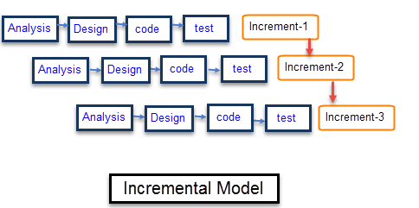

As the above life cycle my project is going to follow the same cycle of development.

Where i am going to develop the design then code for the design after that testing the design. here my mentors/stakeholders are going to give a review about one small part of my project. like that everything is going to be coded , tested at the same time for one small module.then if any modification requires then and then i can change the things .

Why do I choose incremental model ? Because of it’s module function I am going to develop the small module my mentor is going to give the review then an only then i can implement the changes.

Because after developing the whole application then taking reviews then changing any requirements becomes difficult for the developer(me)

## Planning and Scheduling:-

A: Selection of project B: Requirements

C: Finalizing the project

D: SRS(system requirement specification) E: Use case diagram

F: Designing ui

G: Learning new technology for the project/Software H: Creating ui

I: Creating database

J: Designing major backend modules K: Connectivity

L: Test cases/Debugging M: Deployment

|  |  |  |  |  |  |  |  |  |  |  |  |  |  |  |  |  |  |  |  |
| --- | --- | --- | --- | --- | --- | --- | --- | --- | --- | --- | --- | --- | --- | --- | --- | --- | --- | --- | --- |
| TASKS | WEEKS | | | | | | | | | | | | | | | | | | |
|  | 2 | | 4 | | 6 | | 8 | 10 | 12 | 14 | | 16 | 18 | 20 | 22 | 24 | 26 | 28 | 30 |
| A |  |  |  | |  | |  |  |  |  | |  |  |  |  |  |  |  |  |
| B |  |  |  |  |  | |  |  |  |  | |  |  |  |  |  |  |  |  |
| C |  | |  |  |  | |  |  |  |  | |  |  |  |  |  |  |  |  |
| D |  | |  | |  |  |  |  |  |  | |  |  |  |  |  |  |  |  |
| E |  | |  | |  | |  |  |  |  | |  |  |  |  |  |  |  |  |
| F |  | |  | |  | |  |  |  |  | |  |  |  |  |  |  |  |  |
| G |  | |  | |  | |  |  |  |  | |  |  |  |  |  |  |  |  |
| H |  | |  | |  | |  |  |  |  |  |  |  |  |  |  |  |  |  |

|  |  |  |  |  |  |  |  |  |  |  |  |  |  |  |  |  |  |  |  |  |
| --- | --- | --- | --- | --- | --- | --- | --- | --- | --- | --- | --- | --- | --- | --- | --- | --- | --- | --- | --- | --- |
| I |  |  |  |  |  |  |  |  |  |  | |  |  | |  |  |  | |  | |
| J |  |  |  |  |  |  |  | |  |  |  |  |  | |  |  |  | |  | |
| K |  |  |  |  |  |  |  | |  |  |  |  |  |  |  |  |  | |  | |
| L |  |  |  |  |  |  |  | |  |  | |  |  |  |  |  |  | |  | |
| M |  |  |  |  |  |  |  | |  |  | |  |  | |  |  |  |  |  | |
| N |  |  |  |  |  |  |  | |  |  | |  |  | |  |  |  |  |  |  |

## Software and Hardware Requirements:-

* + 1. **Software requirements:-**
       - Jupyter notebook for backend development
       - Visual studio code for frontend development
       - Data handling software sqlite3
       - Access to internet.

## Hardware requirements:-

* + - * A system that can handle the requirement of installing software to implement the project.
      * Ram,Mouse,Keyboard,Processor,Disk Capacity.

## Preliminary Product description:-

Project is about the solving problem of admission process & courses inquiry and svv ,email related query just like a human but here the machine will give answers to the particular questions.

KJBOT will open after clicking the ask me button on kjssc website the page will open and the page contains two questions 1)Admission process & courses related inquiry? 2)SVV-id and email –id related query? With name and Email id filed

The user needs to first fill the name and email-id the If a user chooses an admission process & courses related inquiry? Then the chat page opens, with textfield User and textfield KJBOT and send button when the user enters the query in the input text field, then the system takes the input from the user and then provides a particular output to the KJBOT textfield. if any question is not handled by the KJBOT then the user needs to go to the college for inquiry.

The user needs to first fill the name and email-id the If a user chooses an Svv-id & Email-id related query? Then the chat page opens, with textfield User and textfield KJBOT and send button when the user enters the query in the input text field, then the system takes the input from the user and then provides a particular output to the KJBOT textfield. if any question is not handled by the KJBOT then the user needs to go to the college for inquiry.The name and email id and the option chosen by the user will save into the database so we can analysis the most query is about which admission and courses inquiry or Svv and email-id query

## Conceptual models:-

* + 1. **Use case diagram:-**

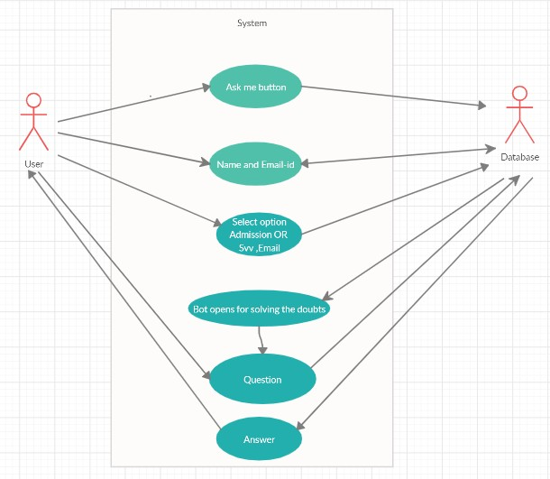

* + 1. **Data flow diagram:-**

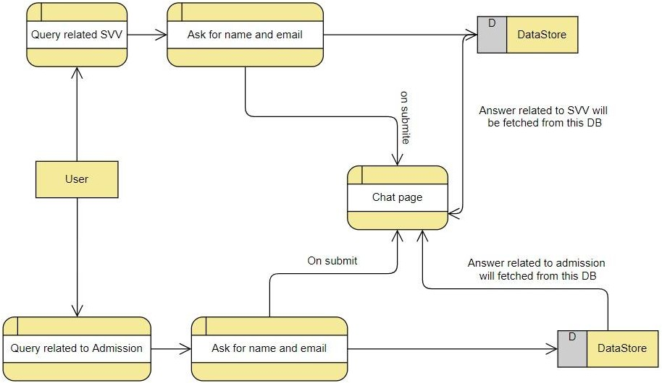

* + 1. **E-R diagram:-**

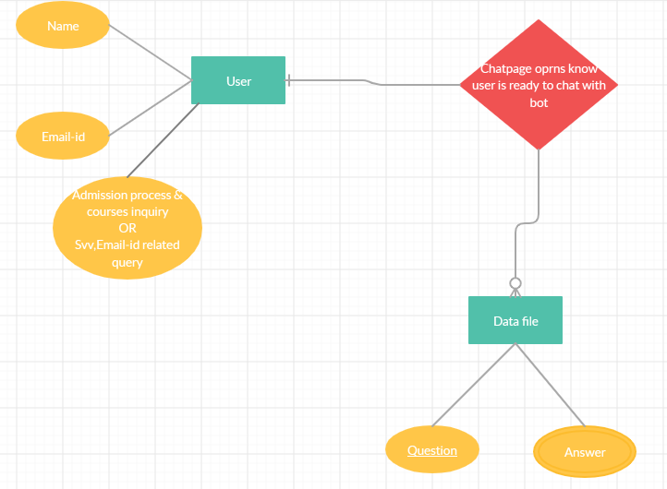

**Chapter 4 : System Design**

* 1. **Significant module in project:-**

Click on button:-after going to the website click on the Askme button

Information page:-after clicking on Askme button the button forward to information page where the database take the name email-id and selecting option

Selecting options:-user have two options then the user needs to select one option. If the user selects an admission process & courses related inquiry then the button will forward to admission chatpage and waits for the user's question.if the user selects Svv-id & Email-id related query it will forward to svv chatpage and waits for the question from the user.

## Data Design:-

After clicking on the Ask me button the next page takes the information from the user like name,email and and the option selected by the user then the .

Name ,Email-id it just gets for the data purpose like how many people have used the website, what is the most selected option and here Email-id is not compulsory only the name and selected option for forwarding to the next page according to the selected option.

According to the selected option the chat page is going to forwarded and particular file is going to execute.like if like if user select the option Svv-id and Email-id related issue then it will go to the backend and run the file SVV where all the data for chat page is present from where the chat page is going to fetch the data.Same for admission process and course related inquiry it will also run the file and chat page is ready to answer

## Procedural Design:-

#### Algorithm Design:-

Step 1. Start

Step 2. Click ask me button

Step 3.Fill name, email-id and selected the option

Step 4. If select option == Svv-id ,Email-id related query

Then it will go to the backend and run the svv file and forward to the KJBOT. After getting the Chat Page type the question and click on the send button and it will go to the data file and gives you the answer

Step 5. If selected option==Admission process & courses inquiry

Then it will go to the backend and run the admission file and forward to the KJBOT. After getting the Chat Page type the question and click on the send button and it will go to the data file and give you the answer.

Step 6. User can go reverse or after getting an answer user can simply close the tab. Step 7. End

## Flowchart:-

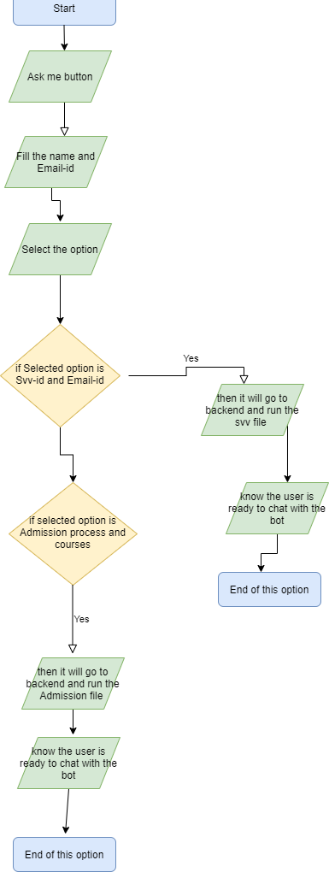

* 1. **User interface Design screenshots:-**

This is the first page for user interaction

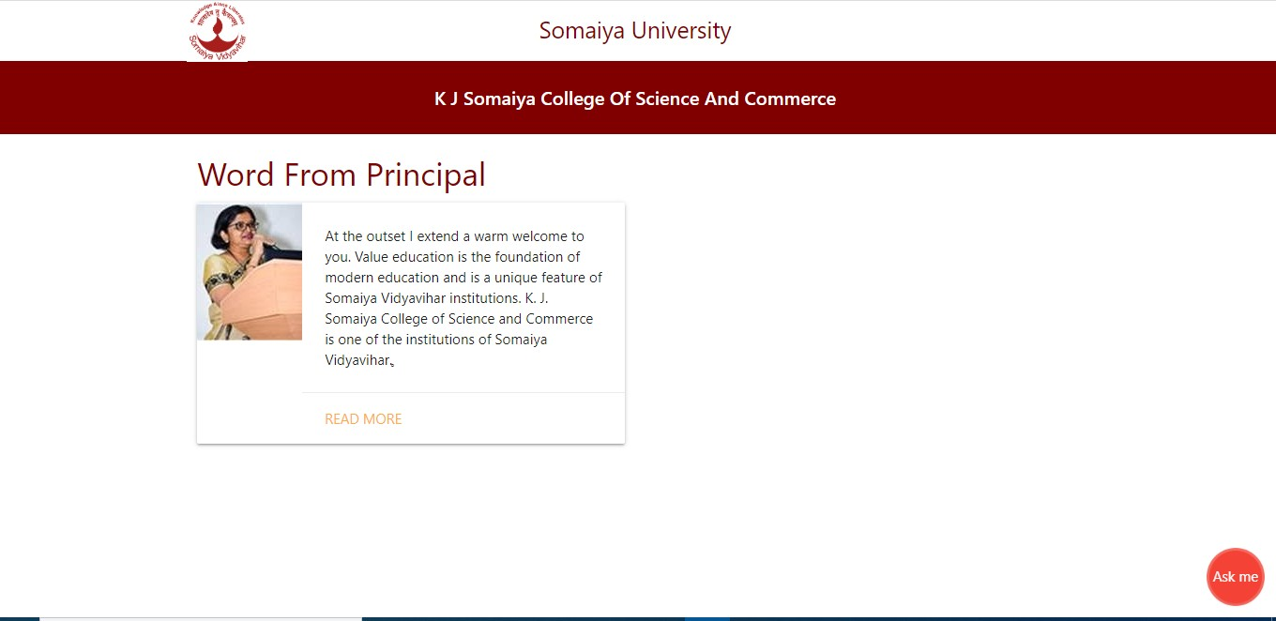

After clicking on ask me button it will forward to the second page ..

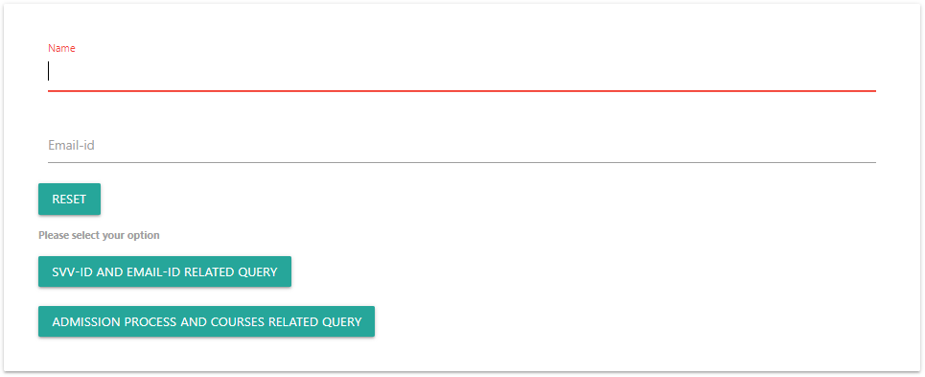

After clicking on Svv-id & Email-id related query

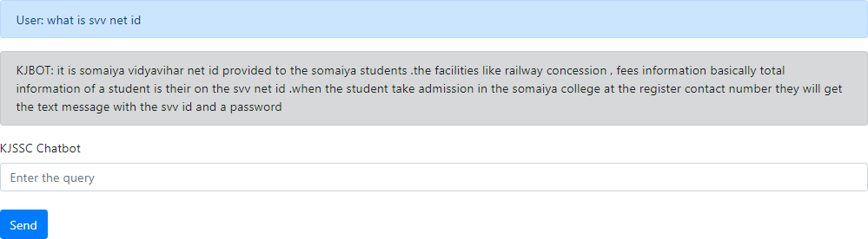

OR

After clicking on admission process and course related query

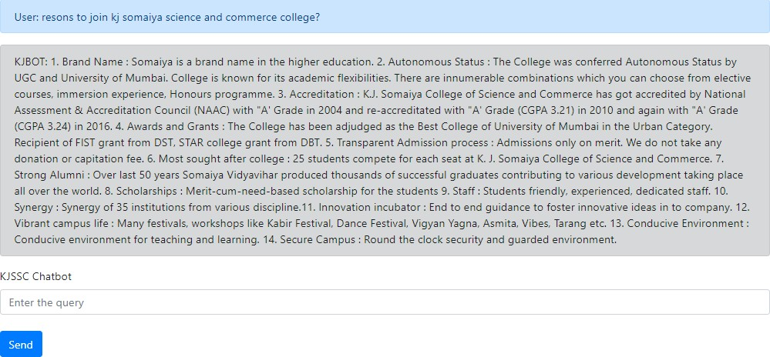

Database entry:

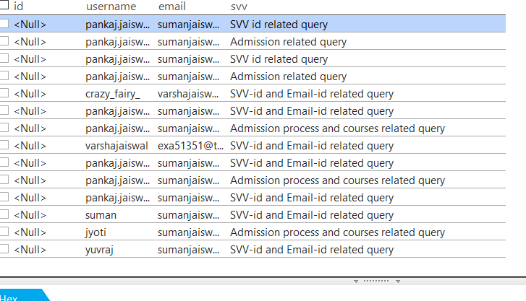

## Security issues:-

In terms of any threat it is a KJBOT which is just taking name and email .

It does not verify the email.

## Testing process:-

In terms of code the testing of code can be done by manually or automatically. here it will test for the application is working properly or not if any bugs are there then the developer can debug that .

now the stakeholders they check the user interface and the working whether it is user friendly or not, what will make trouble to the user while using it?

all the reviews given then the developer takes the suggestion into the consideration and works upon it.

Basically development is based upon

#### “measure ,build and learn”

* 1. **Data dictionary:-**

1st database is which will stores user name and email-id and selected option Table name:-Info database

|  |  |  |  |  |
| --- | --- | --- | --- | --- |
| **Column name** | **Data type** | **Size** | **Constraints** | **Range** |
| Id | Integer | 10 | Primary key | 10 |
| name | String | 20 | - | 20 |
| email-id | Varchar | 30 | - | 30 |
| Selected option | String | 20 | - | 20 |

Second file:- is about admission process and courses inquiry which will contain the answer for the question asked by the user.

Table name:-admission process and courses inquiry

|  |  |
| --- | --- |
| **Column** | **Data type** |
| Question | String |
| Answer | String |

Third file:- is about Svv-id & Email-id related query which will contain the answer for the question asked by the user.

Table name:-admission process and courses inquiry

|  |  |
| --- | --- |
| **Column** | **Data type** |
| Question | String |
| Answer | String |

## Chapter 5 : -Implementation and Testing

* 1. **Implementation Approaches:-**

There are 3 phases in implementation of the project….. Part 1: Setting up the environment

Part 2:Setting up the backend Part 3:Setting up the frontend

Part 4:Connecting the frontend backend and database

#### Part 1: Setting up the environment:-

In this basically the software requires to complete the project to install them and launch them.

Software are :-

1.Jupyter notebook/Python idle 2.Visual studio code

3.Sqlite Viewer

#### Part 2:Setting up the backend :-

In this for backend going to use the jupyter notebook module from anaconda software first i am going to launch that then going to install the modules required like NLTK ,Pandas,Numpy,Keras,Sklearn these are the main modules which is used to mai a bot .

NLTK:-The Natural Language Toolkit is a platform used for building Python programs that work with human language data for applying in statistical natural language processing (NLP). It contains text processing libraries for tokenization, parsing, classification, stemming, tagging and semantic reasoning.

Pandas:-In computer programming,Pandas is a software library written for the Python programming language for data manipulation and analysis. In particular, it offers data structures and operations for manipulating numerical tables and time series

NumPy:- is a library for the Python programming language, adding support for large, multi-dimensional arrays and matrices, along with a large collection of high-level mathematical functions to operate on these arrays. Moreover Numpy forms the foundation of the Machine Learning stack

Keras:- is an open-source neural-network library written in Python. It is capable of running on top of TensorFlow, Microsoft Cognitive Toolkit, R, Theano, or PlaidML. Designed to enable fast experimentation with deep neural networks, it focuses on being user-friendly, modular, and extensible.

Sklearn:-is a library in Python that provides many unsupervised and supervised learning algorithms. It’s built upon some of the technology you already are familiar with, like NumPy, pandas.

THis module has been used for creating a bot in jupyter notebook.

**Part 3:-Setting up the frontend**

For frontend i have used Flask (this is framework for web development in python)basic flask module has been used like..

1.render_template 2.request

3.SQLAlchemy(For database)

The software used for the frontend is visual studio code.

**\**

**Part 4:-Connecting Frontend,Backend and Database**

For connecting the backend which is the Py files to the flask by importing the file after this for connecting the database i have used SQLAlchemy to the flask file .For viewing the data Sqlite viewer software is used.

## Coding Details and Code Efficiency

### Firstly the user click the link then he gets the ,stating page which have ask me button on it code for this button is..

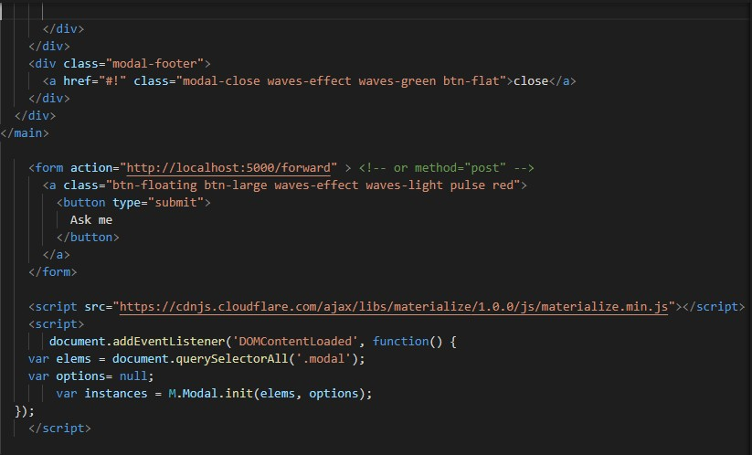

This is the entry page.

1. 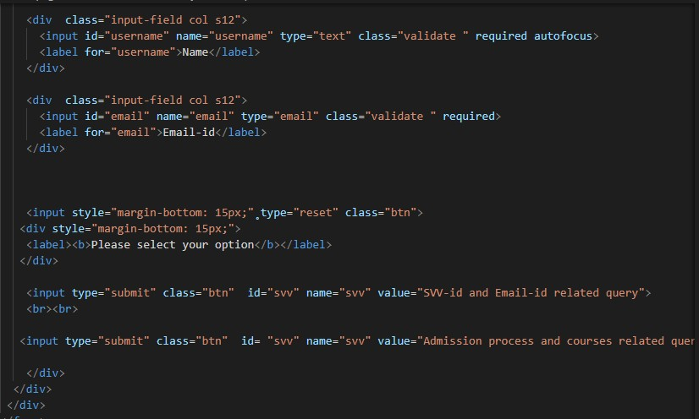After clicking on the ask me button it is going to forward to the second page
2. If the user selects the Svv-id & email-id related query then from the backend the SvvChatbot file is going to run.

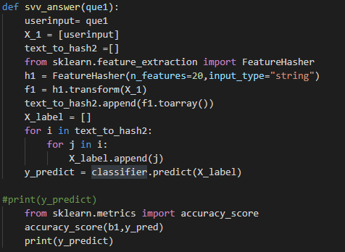

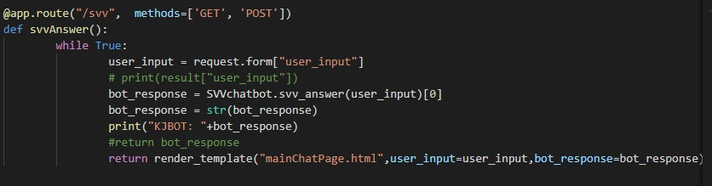And from frontend

The both code are connect as we know after selecting the svv one option these are the main code that is going to execute.

1. If the user selects the Admission process & course inquiry then from the backend the AdmissionChatbot file is going to run.

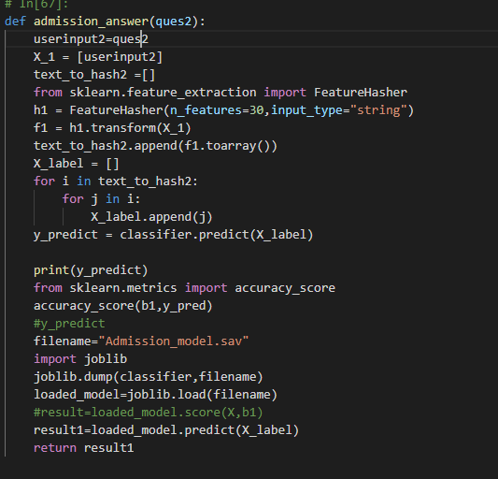

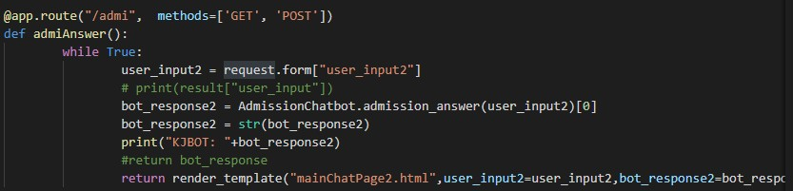And from frontend

1. 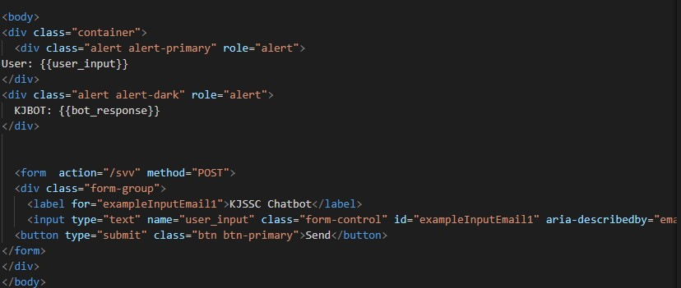Code for the mainchatpage
2. 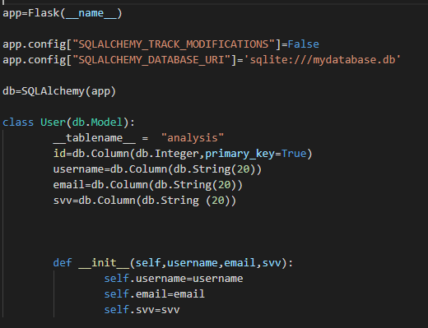Code for the database

## Testing Approach:-

#### Unit Testing:-

1. Ask me button:-After clicking on this button it is going to forward to the next page

.

1. Infomation page:-Here the user have to fill name email-id and select the option. If the user selects Svv-id & Email-id related query then it will forwarded to mainChatpage OR if user selects the Admission process and courses inquiry it will forward to the mainChatpage1 .
2. mainChatpage:-It contains three text fields first is user second is KJBOT and the third text field where the user is going to write the question after clicking on send button the question goes to user text field and and the answer comes from the database into the KJBOT textfield
3. mainChatpage1:-It contains three text fields first is user second is KJBOT and the third text field where the user is going to write the question after clicking on send button the question goes to user text field and and the answer comes from the database into the KJBOT textfield

#### Integrated testing:-

* + - 1. An exception occurs where on the chat page the answer which is given by the bot it appears in this [‘answer’] form
      2. After selecting the option and using the particular bot if user reverse back then click on the another option then the chat page does not appears.

## Modification and Improvements:-

|  |  |
| --- | --- |
| **Error** | Modification |
| The answer given by the bot it is in the brackets | Corrected the chat page API by giving the array index value |
| After reversing from the particular option chat page doesn't show | Their us database error where i have set the email-id as unique attribute so when the user reverse back and select the another option by the same email-id then it shows error. |

**Chapter 6:Result and Conclusion**

**User Documentation:-**

#### Landing page:-



After clicking on the link the page shows like

* Then clicking on Ask me button the user will forward to the next page.

**Information page:-**



* Fill the name and Email-id and select the option the redirect to the next page

**mainChatpage**



* + If the user select the Svv-id & Email-id query option then here the user is ready to chat with the bot.

#### mainChatpage1

* If the user select the Admission process & courses related inquiry then here the user is ready to chat with the bot.

# Chapter 7:Conclusion

## Conclusion:-

The project is about solving the problem regarding the admission process and course related inquiry.While taking admission in any stream or college the process of admission is the main problem that occurs in academics admissions. For students and parents KJBOT have various doubts about the process they come to college for inquiry purposes but for a number of students and their parents college staff is not sufficient.

So here is my project the kjssc KJBOT which will help people to give inquiry about the admission process and courses(for senior college) related doubts also be solved online through the KJBOT so which will be useful and we can save time ,money and energy.

Same for the Svv-id & Email-id related query any question about this the KJBOT will answer .Basically what happens when the new students get the admission in the somaiya college they will get the Svv-id and mail-is but they don’t know how to use that so this bot will answer the question about everything about Svv id and mail-id which will help the it department because of this queries their are so many students ask the same doubts and to tall each and everyone it is pathetic for a faculty so the chatbot is the need.

For creating this bot the technology used is machine learning which basically means to make machine learn with the data.and so i have created my limited data for the bot and it is know able to answer the questions asked by the user.for backend jupyter software is used , for the frontend the flask and for the database Sqlite.after connecting the frontend and backend the project is ready.Now the user can use that and ask question as many question they want to ask.

## Limitations of the System:-

While creating the project I have mentioned some limits to it. It is more or less important for the better user experience.

#### Anyone can use without any credentials:-

Here the email-id is not necessary for the particular by entering name and selecting the option the person is able to use the bot. As We know the Svv-id and Email-id related query is for the somaiya students but anyone can use that bot.

#### Spelling mistake :-

While chatting with bot spelling mistakes are not allowed the spelling should match with the fetching data files.

#### Limited data:-

As this data i have created on my own with the help of college prospectus so the data is limited if the user enters the question which is not in the fetching data file then the bot will answer any random answer.

## Future enhancement:-

1. Future enhancement for my project will be like here i am making my chatBOT for only KJSSC admission process & courses inquiry and svv and email id related issue.it will be enhanced and use by other college and after getting the lot of data the chat KJBOT will give the most efficient answer .
2. Spelling mistakes are not handled by the bot. It gives random answers so for future this feature can be added after getting spelling mistakes. It will take care of that and provide the correct answer.
3. If any important notice is there so the chatKJBOT can display as headline on the page
4. can minimize the user interface structure means at this time the bot is taking 100% of the page so can make to 30-40% of the page
5. Email verification system..

## References:-

**1.h**

**2.h**

**3.h**

## ttps://hackersandslackers.com/flask-sqlalchemy-database-models/ ttps://code.visualstudio.com/docs/python/tutorial-flask

**ttps://scikit-**

**l earn.org/stable/modules/generated/sklearn.feature_extraction.Featur e Hasher.html**

1. **h** [**ttps://www.datacamp.com/community/tutorials/svm-classification**](http://www.datacamp.com/community/tutorials/svm-classification-)**-**

**s cikit-learn-python**

1. **h ttps://stackabuse.com/implementing-svm-and-kernel-svm-with-**

**p ythons-scikit-learn/**

**Udemy course:-**

**NLP - Natural Language Processing with Python**